Contents

The Tile Editor 1

Downloading a TileMap 2

tile maps 3

The TileMap components 4

The Tile Palette 5

Group Placement 6

Individual Placement 6

Editing the GamePalette 7

The Game Palette Toolbar 7

Drawing to the scene 8

Ordering Layers 8

# The Tile Editor

Unity uses a series of tools to help easily draw sprites to the scene.

There are a series of components and tools used to make a tile editor

### Grid

The Grid component is a guide which helps to align GameObjects based on a selected layout. The component transforms grid cell positions to position the tiles in the tilemap to the screen

### 

### Tilemaps

A tilemap handles tile assets in to assist in drawing the tiles to the screen, it uses the Grid to determin positioning of the tiles drawn to it.

### The Tile Palette

The tile palette creates and stores a tile palette to be painted onto the tilemaps. It contains a series of tools to help set up a palette of tiles and draw them into the scene.

# Downloading a TileMap

We have provided you a tile map you can use for this tutorial, called tileset. We set this up in the last tutorial.

If you wanted your own sprite sheets you can gather some online

<https://opengameart.org/> is a repository of open source art resources that you can use. It has a good selection of usable tilemaps and assets. Be aware on the licencing agreement even if it is free as the creator still has rights to their work.

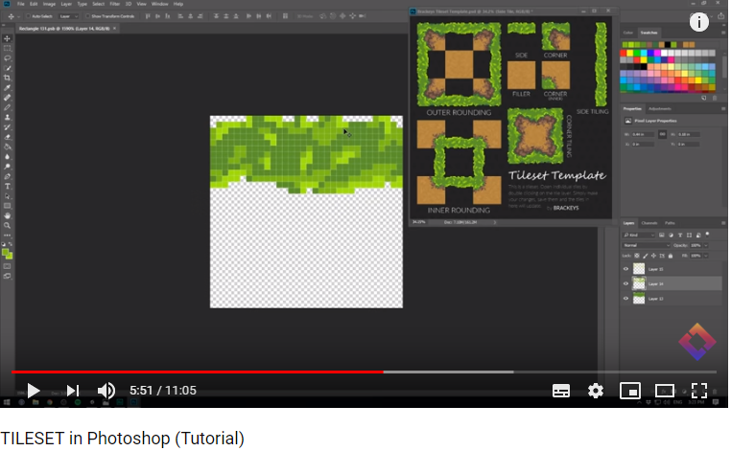

You can even create your own tile maps.Here is a good tutorial from youtube Unity teacher Brackeys

<https://www.youtube.com/watch?v=aaEEujLtsr8>

It is a good in-depth look at how to use extra tools in photoshop as well as make tiling tiles.

# tile maps

A tile map is a layer which we can paint tiles to. Each tile map can be layered on top of each other to allow objects behind or in front of each other. You can add components to a tile map to add functionality to that layer.

To create our tilemap

1. Select GameObject -> 2D Object -> Tilemap

This will add a Grid GameObject to the array with a child game object which is where the TileMaps are stored

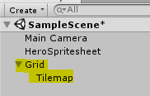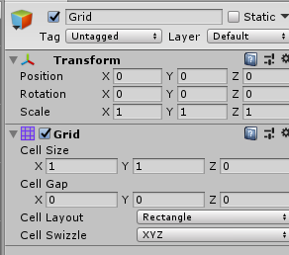Just like with Unitys UI system, when we create a new Tilemap, it will be placed within the Grid. They need to be in here to render to the scene.

1. Rename the tilemap to represent what it contains
   1. Ie – Platforms, background, foreground, etc

In the Grid game object, you can see a script called Grid. From here we can change the cell size to say how big a tile is. As we have adjusted our tile size to fit one unit, it will fit in a 1 by 1 cell.

Now we have our grid. How do we draw to it?

# The TileMap components

The Tilemap game object comes with two components

### Tilemap

This allows you to play around with how the tilemap works

* **Animation Frame** – Tiles can be animated. This determines how fast the animation plays
* **Color** – Tints the tiles with this colour
* **Tile Anchor** – Determines the offset of the tiles to the tilemap. By default, it tries to centre the object.
* **Orientation** – Orientation on a 3D plain.

### Tilemap renderer

This is like the renderer for 3D objects. It sets up how it draws the tilemap

* **Material –** Defines the material used to draw the tiles on. This effects how lighting works on a sprite
* **Order in Layer –** This determines what gets drawn on top of other tiles. Low numbers get drawn first, high numbers get drawn last making it draw over previously drawn on areas
* **Mask Interaction** – Sets up how a tile works when interacting with a mask

# The Tile Palette

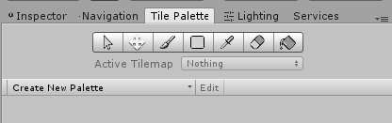The Tile palette allows us to set up what sprites are used for our tiles. Here we can setup different pallets, choose which tile map to draw to and draw to the tilemap

The Tile Palette is its own window which we will need to open.

1. Open up a tile palette window
   1. 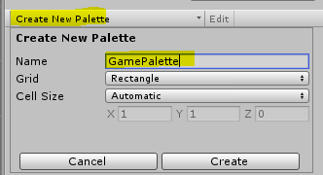Window - > 2D - > Tile palette

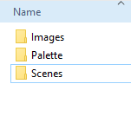

1. Set the window into a useful location

Before we can draw, we need a Palette of tiles to draw from

1. Click “Create New Palette”
2. Call it GamePalette

It will ask you to choose a location to save it,

1. Create a folder called palette
2. 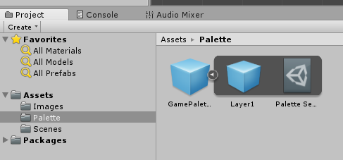set it to that folder



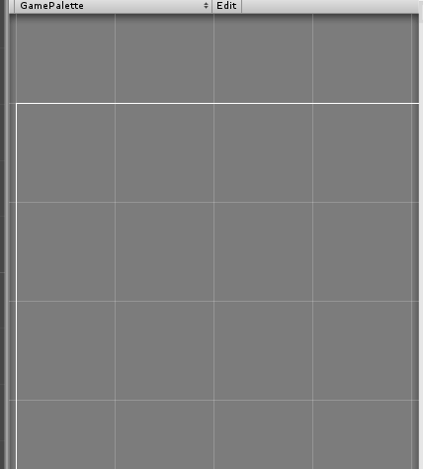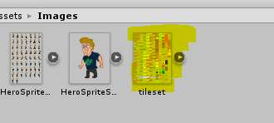Now we have a Palette, we need to add some sprites to it.

## Group Placement

In the Tile Palette, there is a large space that you click and drag the tiles in.

1. Select the main tileset
   1. NOTE: Don’t select each tile inside individually, it will not order it well
2. 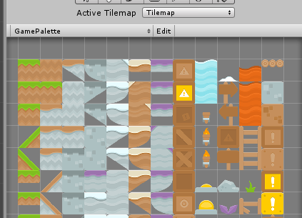Click and drag it into the space in Tile palette
   1. 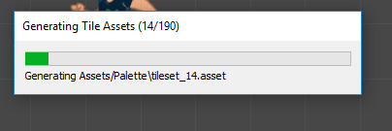You should see a grid appear and a white outline where the tiles will place
3. Chose a location for the tile assets to be stored
   1. I put them in the Palette folder

Unity should generate the Tile Assets. Once done, you should see all the tiles in the palette

## Individual Placement

You can also drag each tile individually to choose selective placement on the grid

Careful, if it is the wrong size, it may look like this

## Editing the GamePalette

You can make edits to the palette by pressing the Edit button.

From here you can use the toolbar to select, move, and remove tiles from the palette.

## The Game Palette Toolbar

There a selection of tools that are used to both edit the gamePalette and draw to the scene

* **Select** – can select one or click drag to select multiple
* **Move** – Moves a selected section of tiles
* **Paint –** paints a tile to the tilemap
* **Square Fill** – click drag for filling in a square
* **Eye dropper** – when you select a tile in the scene, it will find and select it in the pallet
* **Erraser** – Erases a tile
* 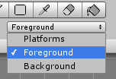**Fill** – Will fill a section of the scene. Gets a little buggy when not in a contained area

### The Active Tilemap

This is where you chose which tilemap to draw on

**NOTE: YOU DO NOT CHOSE IT IN THE HIERARCHY**

From here you can select the different tilemaps in the scene to draw on.

# Drawing to the scene

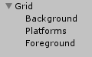Now that we have the palette set up and know the tools. Let’s draw some tiles.

1. Create a few tilemaps for different layers
   1. Background
   2. Platforms
   3. Foreground

* 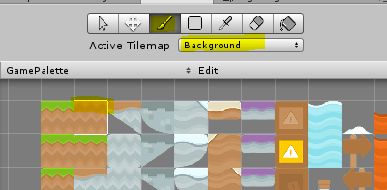In the Tile Palette Window

1. Select a tile you wish to draw
   1. Make sure you are NOT in edit mode
2. Chose the paint tool
3. Select the Active Tilemap you wish to draw to

* In the Scene

1. Draw the tile

Have fun, and play around with the tools to create a little level

## Ordering Layers

At the moment, all the layers are on top of each other. To determine which order they are in we need to set that in the Tilemap Renderer component.

1. Select the layer you wish to change

* In the Inspector
* In the Tilemap renderer component

1. Set the Order in Layer Value
   1. Low for background high for foreground

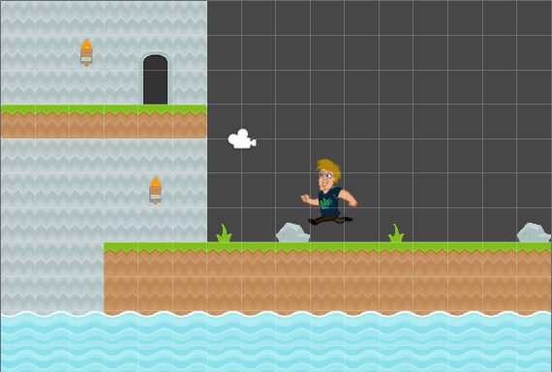

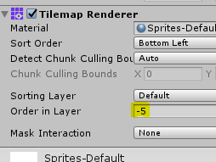

**NOTE: If you want background items, like torches, create another background layer called background items. Make sure it is in front of the background and you can draw it onto that layer.**